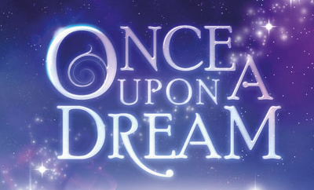
Student Planning Sheet

What do you dream about?
Decide what sort of dream your story will be about. Is it a dream for the future or a dream you’ve had, either good or bad? Or will your imagination run wild and create a whole new dreamworld?

What can you see?

Who are you with?

Where are you?

How do you feel?

What happens?

Write any other ideas here:

