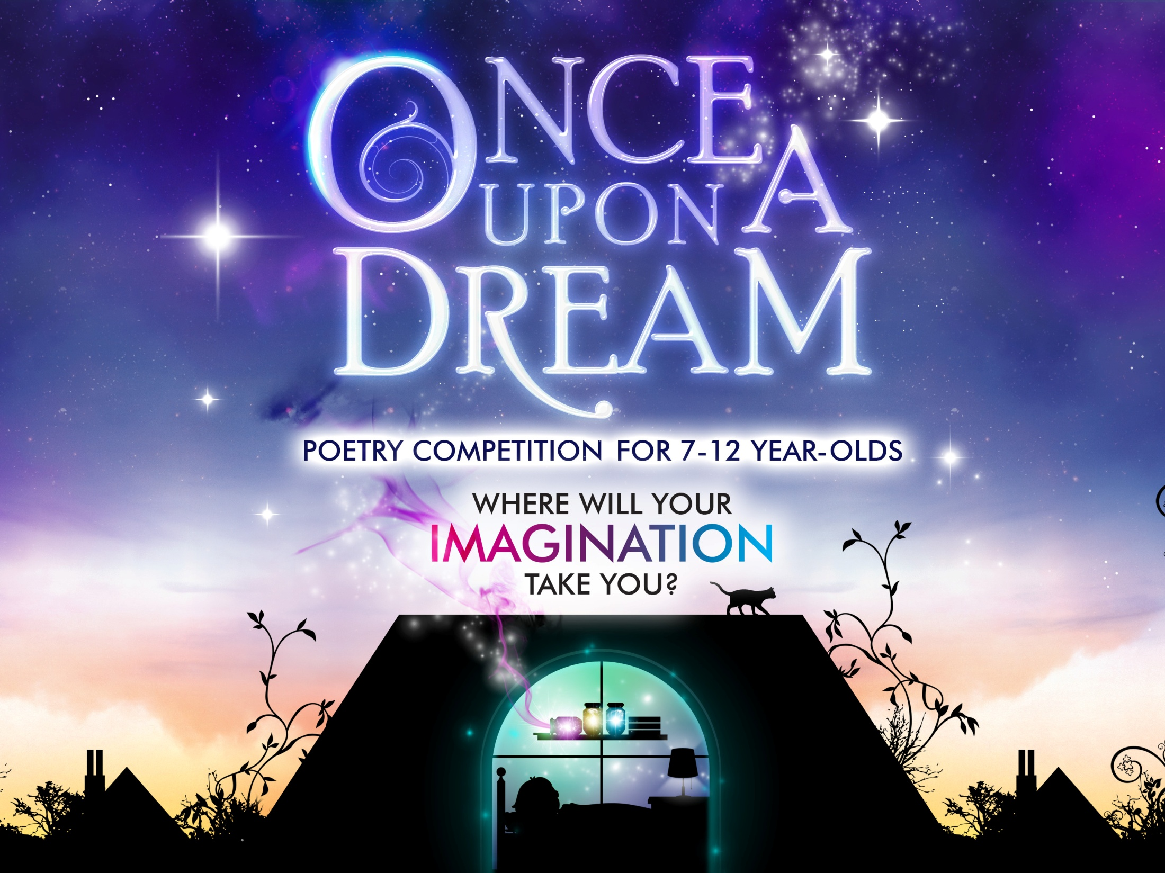

**Story Writing Competition for P4-P7**